Dahye Chung

Game 250

Audacity 1

Breif Introduction:

This sound is for RPG adventure game sound. The main theme sound is played inside of the town. The second sound in the middle is when the player enters the dungeon. The sound tempo changes fast when the player faces enemies.

Sound Technique Used:

1. Split Clip & Time Shift
2. Fade in & out (change location)
3. Cross-Fade (so
4. Tempo Change (Enemy faced in dungeon)
5. Reverb (expressing dungeon environment)

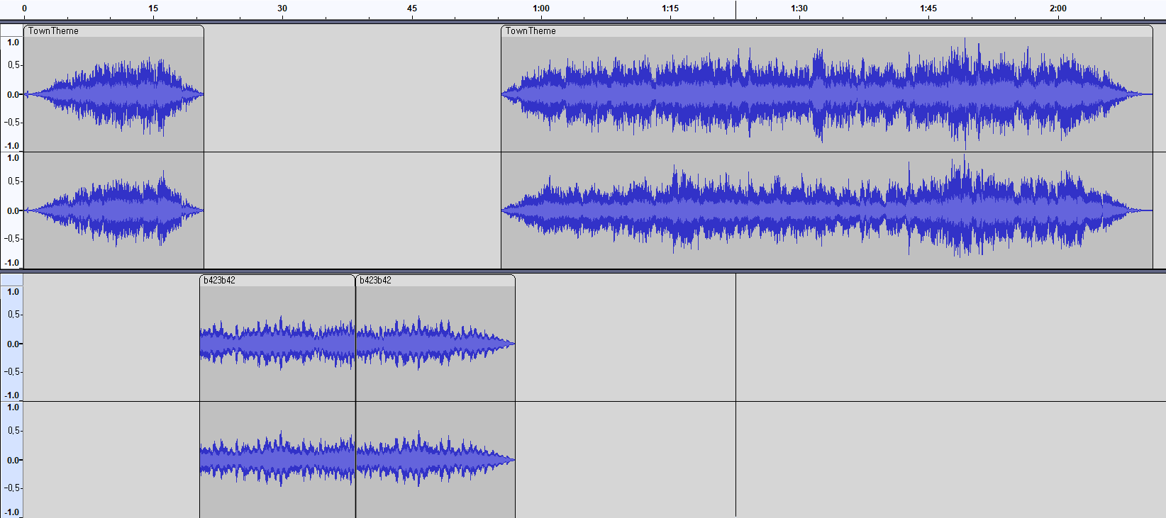

Reference:

1. OpenGameArt : <https://opengameart.org/content/loading-screen-loop>
2. OpenGameArt : https://opengameart.org/content/town-theme-rpg